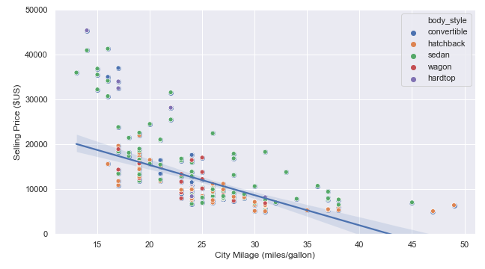

**Description :**

Figure showing a *robust* ***linear***fit between the selling price and the cars mileage in cities for all vehicle types.

**Sources:**

Simple_regression_example_using_parametric_and_non_parametric_methods.ipynb

Parametric fit (Linear fit) all cars.png

Parametric fit (Linear fit) all cars.pdf

**------------------------------------------------------------------------------------------------------------------------------------------**

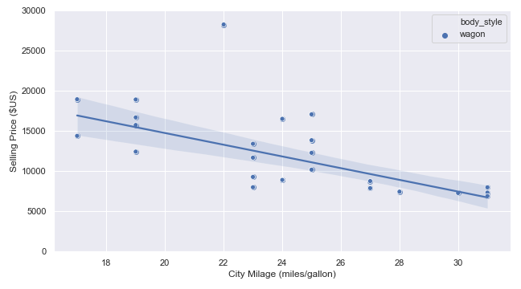

**Description :**

Figure showing a *robust* ***linear*** fit between the selling price and the cars mileage in cities for wagon vehicles only.

**Sources:**

Simple_regression_example_using_parametric_and_non_parametric_methods.ipynb

Parametric fit (Linear fit) wagon cars.png

Parametric fit (Linear fit) wagon cars.pdf

**------------------------------------------------------------------------------------------------------------------------------------------**

**Description :**

Figure showing a *robust* ***non-linear*** fit between the selling price and the cars mileage in cities for all vehicle types.

**Sources:**

Simple_regression_example_using_parametric_and_non_parametric_methods.ipynb

Non-parametric fit (LOWESS) all cars.png

Non-parametric fit (LOWESS) all cars.pdf

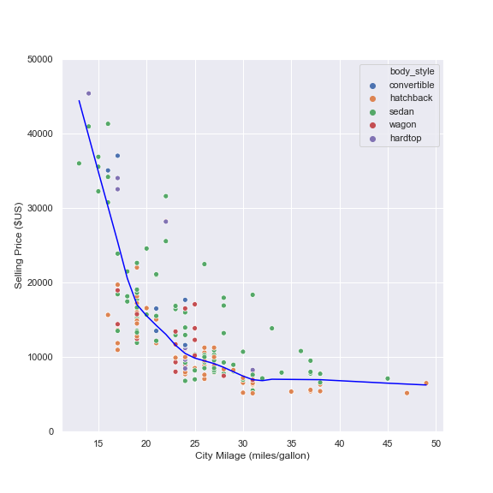

**------------------------------------------------------------------------------------------------------------------------------------------**

**Description :**

Figure showing the effect of polynomial order on fits with a **small** dataset and a **small** noise level.

**Sources:**

genere_regression_examples_with_polynomial_of various_orders.ipynb

Polynomial_fits_with_small_N_and_small_sigma.png

Polynomial_fits_with_small_N_and_small_sigma.pdf

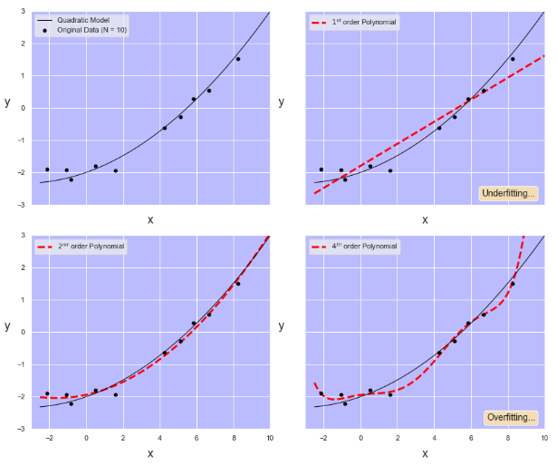

**------------------------------------------------------------------------------------------------------------------------------------------**

**Description :**

Figure showing the effect of polynomial order on fits with a **large** dataset and a **small** noise level.

**Sources:**

genere_regression_examples_with_polynomial_of various_orders.ipynb

Polynomial_fits_with_large_N_and_small_sigma.png

Polynomial_fits_with_large_N_and_small_sigma.pdf

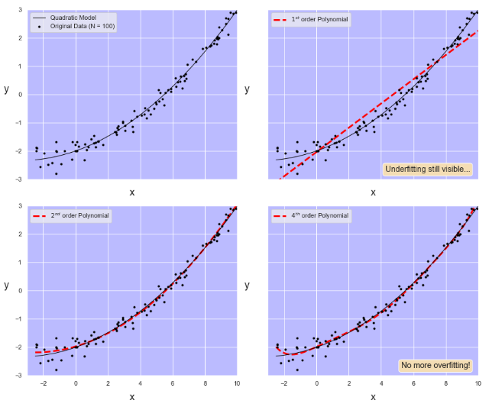

**------------------------------------------------------------------------------------------------------------------------------------------**

**Description :**

Figure showing the effect of polynomial order on fits with a **large** dataset and a **large** noise level.

**Sources:**

genere_regression_examples_with_polynomial_of various_orders.ipynb

Polynomial_fits_with_large_N_and_large_sigma.png

Polynomial_fits_with_large_N_and_large_sigma.pdf

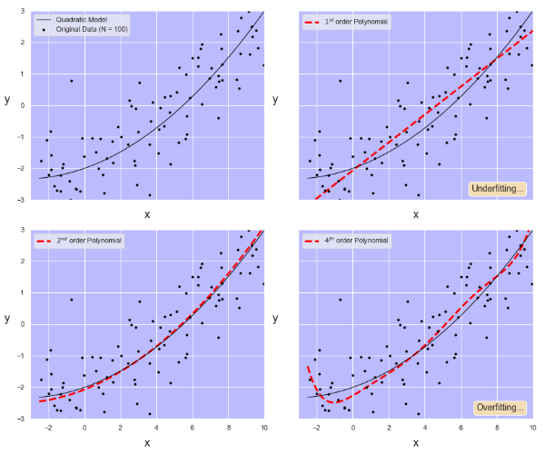

**------------------------------------------------------------------------------------------------------------------------------------------**

**Description :**

Video showing the effect of polynomial order on fits with a **large** dataset and a **small** noise level.

**Sources:**

genere_regression_examples_with_polynomial_of various_orders.ipynb

Effect_of_dataset_size_on_fits.avi

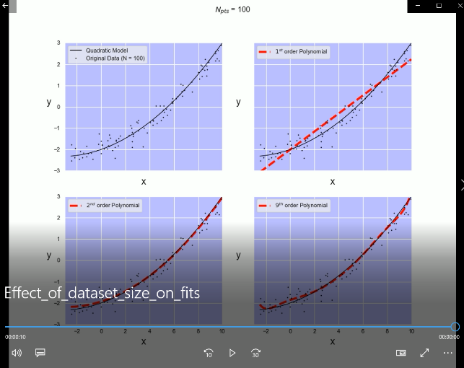

**------------------------------------------------------------------------------------------------------------------------------------------**

**Description :**

Video showing the effect of noise level on fits with a **large** dataset.

**Sources:**

genere_regression_examples_with_polynomial_of various_orders.ipynb

Effect_of_noise_level_on_fits.avi

